Usage documentation

Contents
1. Layout of website 1
2. Navigating to and completing common tasks 3
2.1 Viewing the database 3
2.2 Recording chamber logs 4
2.3 Adding a new test 5
2.4 Registering DUTs/Harnesses 5
2.5 Recording tests a DUT/Harness underwent 5
2.6 Registering programs and their test maps 5
2.7 Linking items together, list of items that link together 5
2.8 Adding a new test type 5
2.9 Program hours calculation 5

Layout of website
Our website has many pages, all has been linked to a menu bar for ease of navigation. The menu bar is shown below (grey bar), and it is present at the top of every page.
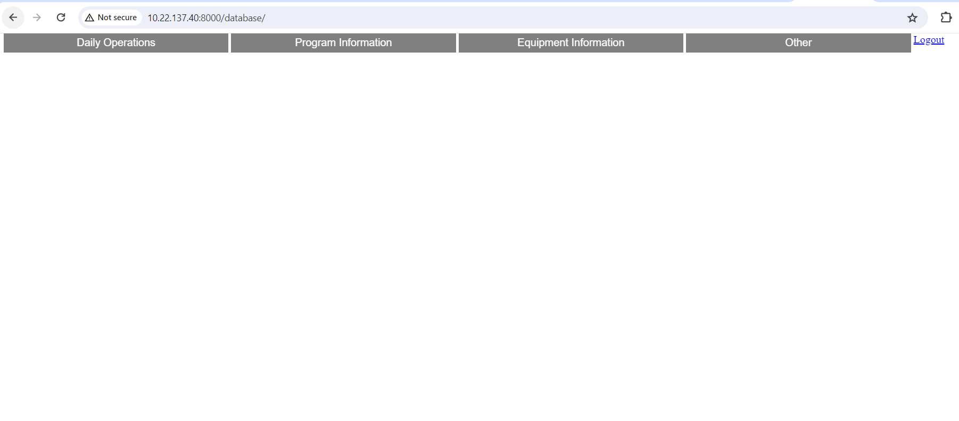
Figure 1 - Grey menu bar
The web pages are split into four categories:
- Daily Operations – Pages that will likely be visited for daily tasks.
- Program Information – For viewing, adding program information to the database, in order to schedule tests.
- Equipment Information – For viewing, adding equipment information to the database, and keeping track of our equipment.
- Other – Miscellaneous information and program-hours calculation.
To see the web pages for each category, hover over the bar of the category and a drop down list will appear with the web pages for that category. Each web page link will be highlighted as you hover above it to let you know what you are clicking on.
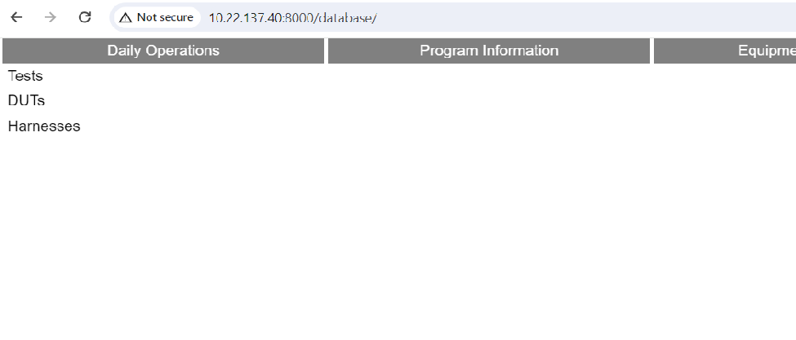
Figure 2 - Menu bar hover over "Daily Operations"
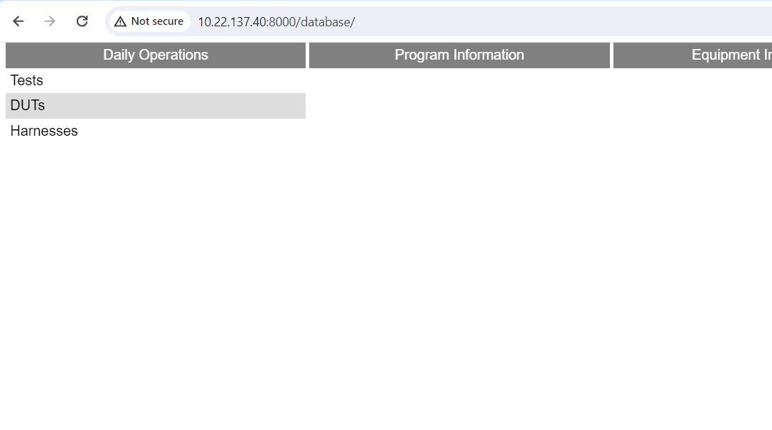
Figure 3 - Hover over "DUTs"

Navigating to and completing common tasks

Viewing the database
Pages will show information on items that their titles list. For example, if you wanted to view information on DARs, you would click on the “DARs” page in “Equipment Information”.
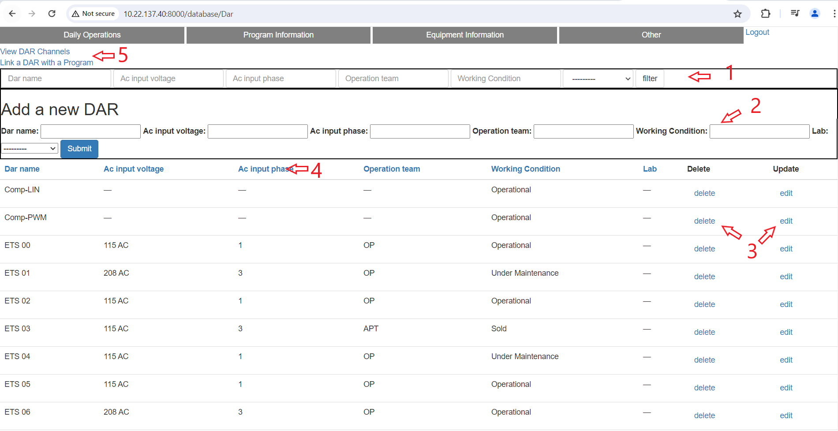
Figure 4 - DARs page
There are around 5 features on any page on our website. They are indicated by numbers in the Figure 4 above.
1 – Filter bar: The filter bar helps to filter items listed in page’s table. Each table heading have an input box for the user to filter as they like. Click “filter” and the items displayed in the table will only be those that match the filtering criteria.
2 – Addition bar: This is used to add insert an item into the database. The newly added item will be displayed in the table after clicked “submit”.
3 – Delete, Edit buttons: Delete an item in the database, edit fields of items in the database.
4 – Sort: Click on a table heading to sort items in the table by that header.
5 – Additional Links: Some pages have additional links to avoid crowding the menu bar and the need to memorize many page addresses to do common tasks. Tasks and things related to DARs can all be found on the “DAR” page, the same applies to other items.

Recording chamber logs
Go to “Tests” page in “Daily Operations”. Look for the test that you are making the chamber log for. Click on the “log” button on the line of your test.
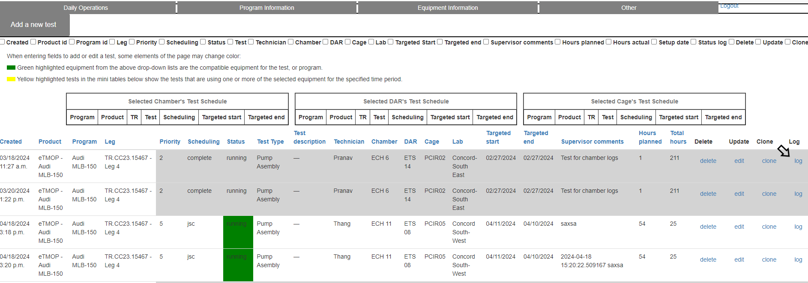
Figure 5 - Log button on "Tests" page
Clicking the button will open up a new page where all the logs for that test are displayed
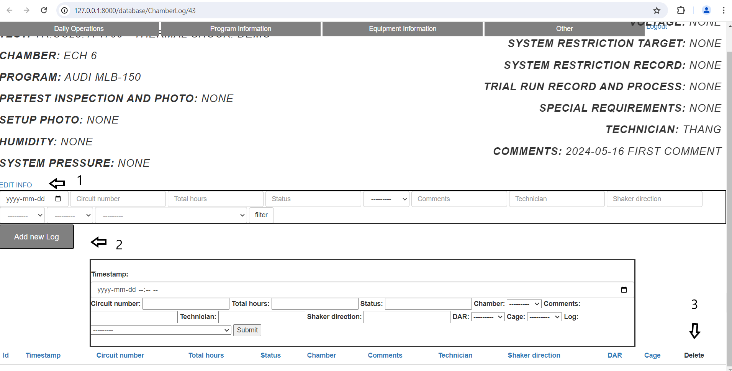
Figure 6 - Chamber Logs Page
The features on this page are:
1 – Edit general test information: click this to change the chamber set up information (written in bold in the top half of the screen).
2- Add a new log: click this to display the form in the lower half of the screen with the “submit” button. Filling out this form and submitting will add a new log to the test.
3- Delete log: click this to delete a log of the test.

Adding a new test
Go to “Tests” in “Daily Operations (1), click on “Add new test”, then submit (2). In case the test type is a new one or is not in the database to select when filling in test information, go to “Add new test type” in “Other” and add in a new test type. Below the “Submit” button are two search tools for the user to search for products and programs that the test is for. This is to search the drop down lists for these items when filling out the test details.
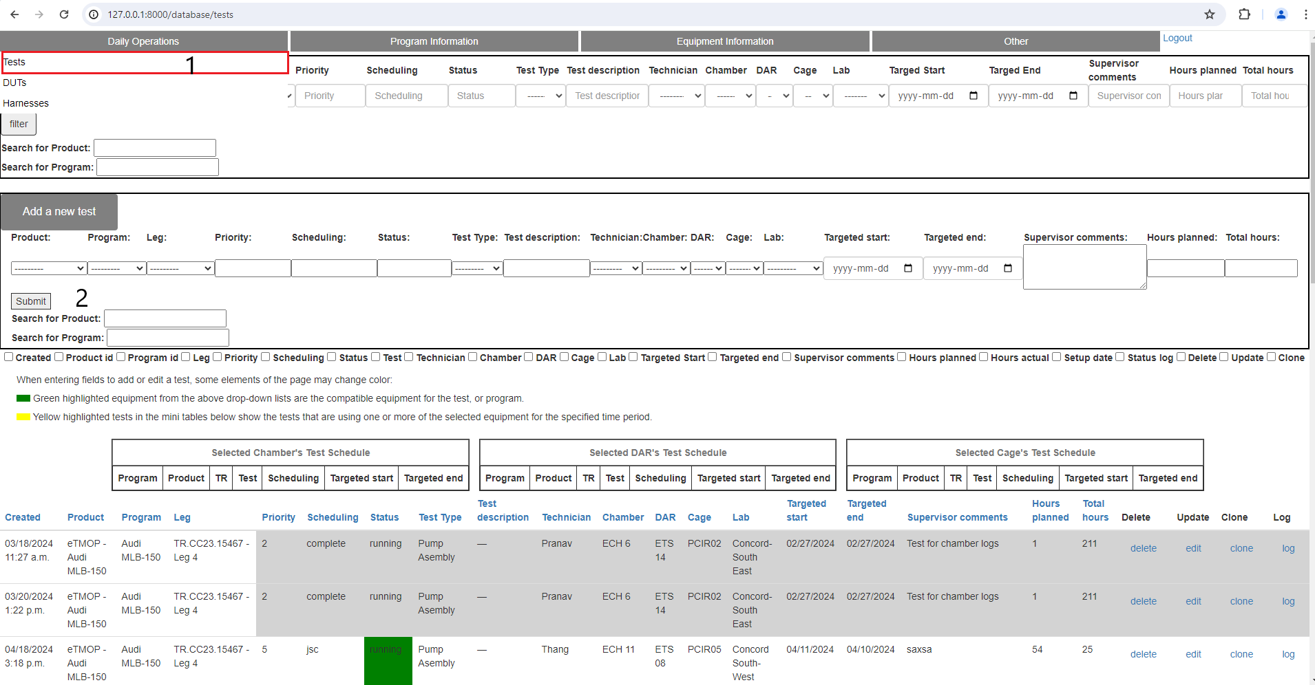
Figure 7 - Tests page

Registering, viewing DUTs/Harnesses
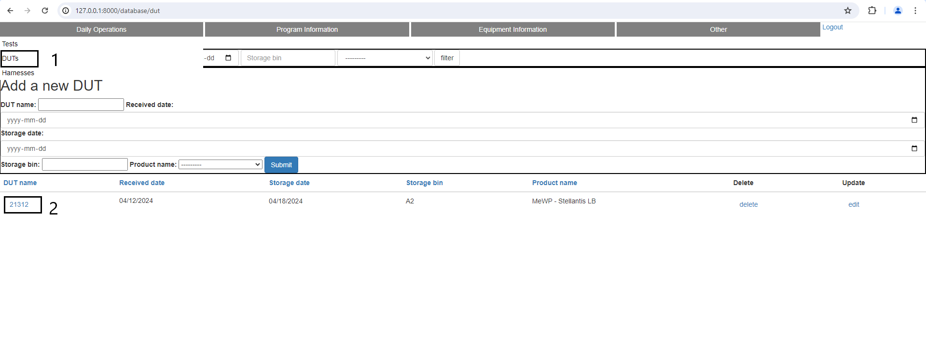
Figure 8 - DUT Page
Go to “DUTs” or “Harnesses” in “Daily Operations” (1), enter the form under “Add a new ___” and click submit. To view the history of Harnesses or DUTs, click on the name of the Harness or DUT that you want to view (2).
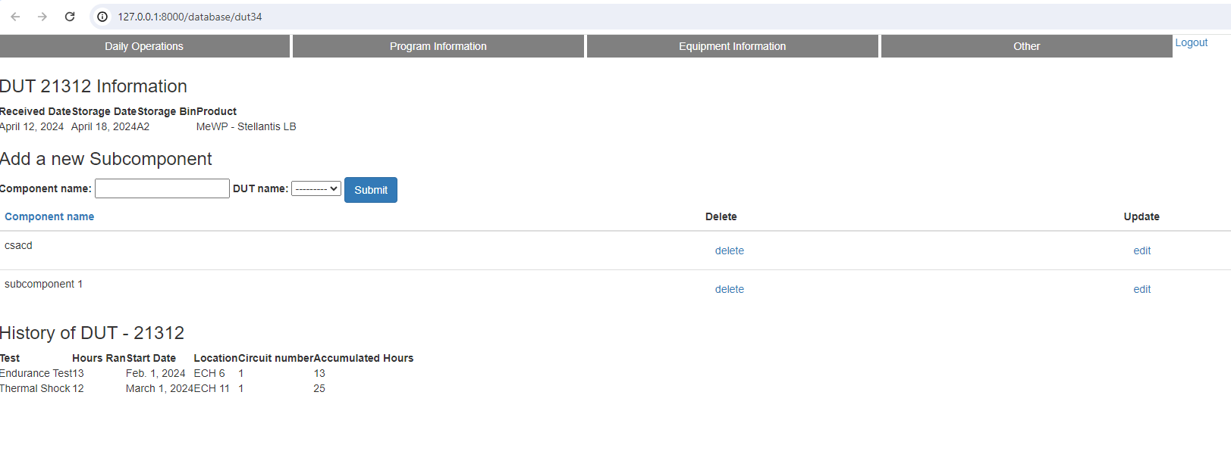
Figure 9 - DUT Info page
For DUTs, you can further add to them subcomponents on the detailed information page that pops up after clicking the name of the DUT. To do this, fill in the form and click submit.

Recording tests a DUT/Harness underwent
At the top of the “DUTs” page is a link called “Link DUT with a test”. Click this to link tests and DUTs together. Each link denotes a test that a DUT underwent. A similar link is also on the “Harnesses” page.
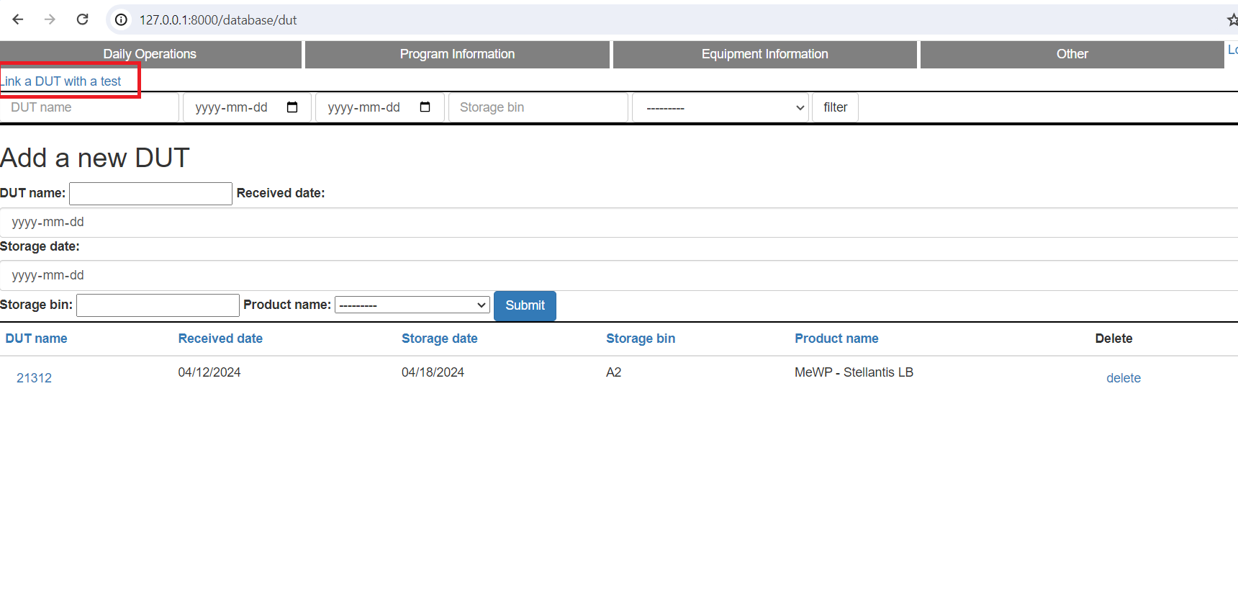
Figure 10 - DUT page
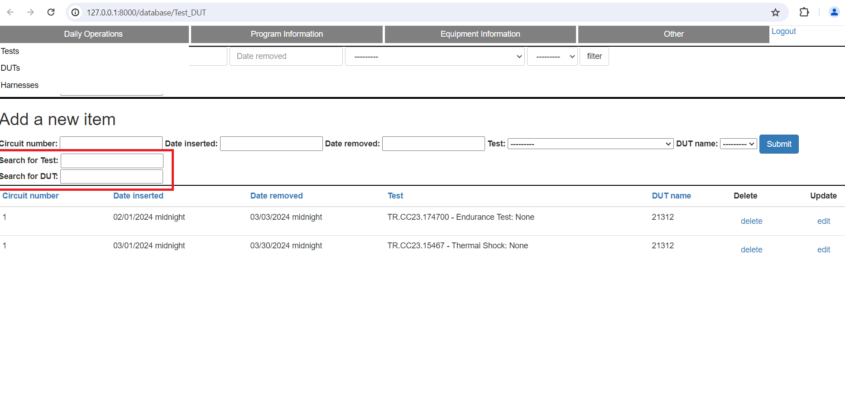
Figure 11 - Test_DUT page
Under the form used to fill out what DUT to link with what test, there are two search tools highlighted with a red box used to look up the test and DUT from the drop down list.

2.7 Linking items together, list of items that link together
Like linking DUTs/Harnesses to Tests, there are other items that link to together as well. The below list shows the pairs that link together, as well as the purpose of linking them.
- Tests-DUTs: to keep the history of DUTs
- Tests-Harnesses: to keep the history of harnesses
- Chamber-Test type: to know the test types that a chamber can run. The chambers that can run a certain test type will be highlighted when adding a new test and the test type has been selected.
- DARs-Programs: to know the DARs that are compatible with a program. The compatible DARs will be highlighted when adding a new test and the program has been selected.
- Cages-Programs: same reasoning as above
- Test Fluids-Programs: same reasoning as above
- Laptops-DARs: to keep track of the location of laptops
- Technician-Technician Skills: to know the capability of technicians for assigning tests

2.9 Program hours calculation
Go to “Program Hours Calculator” in “Other”. Select the start date and end date for the period in which you wish to calculate program hours. Click calculate and download the csv file containing the program hours in the new web page. Some rules for accurate program hours calculation:
1 – make sure that the technicians enter in all the status changes, correct times for status changes in their chamber logs.
2 – Record the end date of the last calculation. Make this the start date of the next calculation, this way no chamber logs are skipped or double counted.

